CAP Meme quiz

This quiz can help you raise awareness on the Common Agricultural Policy of the European Union during events or workshops and start the conversation with participants in an interactive way.
The quiz includes 8 questions. Each is marked in a different color. For each question there are 3 answer options.
Easy introduction:
- Print the three sheets with questions and memes that indicate if the right answer has been picked in full color.
- Cut and stick on cardboard to make it more robust.
- Print the sheets with the three answer options for each question in full color, glue them on cardboard and cut them into cards.
- See list of all questions and correct answers on the last page and arrange the cards with answer options in right order by placing the 3 cards with answer options for each question above the solutions.
- Now the quiz is ready to play.
What does the abbreviation CAP mean? |  | YEY! YOU ARE RIGHT!  The Common Agricultural Policy is the agricultural policy of the EU. It implements a system of agricultural subsidies and other programmes including rural development. It has been criticised for its lack of social and environmental ambition.
How much of the EU’s budget is spent on agricultural policy (in %)? |  | 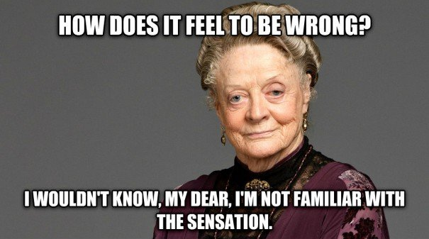 | YEY! YOU ARE RIGHT!  Every year, 58 billion Euro, almost 38 percent of the EU budget, are spent on the EU Common Agricultural Policy.
What is the average size of a farm in the EU? |  |  | YEY! YOU ARE RIGHT!  Farms have an average size of 16.1 hectares per agricultural holding. Farm sizes vary widely in different EU countries, from an average of 3 hectares in Romania to 133 hectares in the Czech Republic.
A big share of the CAP is paid as direct payments to farmers. How many of all recipients are getting 80% of the payments (in %)? |  | YEY! YOU ARE RIGHT!  Direct payments reinforce inequality among farmers, with the bulk of it going to large-scale, industrial farms. Across the EU as a whole, 80 percent of such payments go to just 20 percent of farms.
How many farms had to give up their business in the last 10 years in the EU (in %)? | 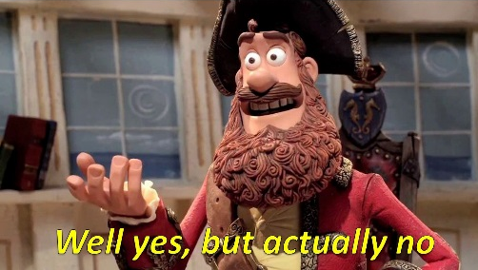 |  | YEY! YOU ARE RIGHT!  In just ten years, the whole European Union lost one third of its farms. Mostly small farms have to give up, while the big ones keep growing.
What is the land area covered by agriculture in the EU (in %)? | YEY! YOU ARE RIGHT!  Agricultural land covers 175 million hectares or 1.750.000 km² in the EU. This is around 40 % of the total land area of the EU.
How many of Europe’s farmland birds population has been lost within the last 40 years | YEY! YOU ARE RIGHT!  In the last 40 years Europe has lost over 50% of its farmland birds.
How many percent of farms manage more than half the agricultural land in the EU today? (in %) |  | 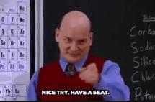 | YEY! YOU ARE RIGHT!  In the EU 3,1% of all farms manage 52.2 % of farmland in Europe.

Capable Agrarian Politics | Common Agricultural Policy | Comprehensive Agricultural Policy
21% of the EU household | 51% of the EU household | 38% of the EU household
Around 150 hectares per farm. | Around 81 hectares per farm. | Around 16.1 hectares per farm.
80% of the direct payments go to 75% of the farms. | 80% of the direct payments go to 20% of the farms. | 80% of the direct payments go to 40% of the farms.
In the last 10 years over 30% of the farms had to close down. | In the last 10 years around 20% of the farms had to close down. | In the last 10 years around 10% of the farms had to close down.
Around 40% of the total land area in the EU | Around 28% of the total land area in the EU | Around 61% of the total land area in the EU
Europe has lost over 50% of its farmland birds. | Europe has lost over 15% of its farmland birds. | Europe has lost over 65% of its farmland birds.
13,7% Manage more than 50% of agricultural land in Europe | 20,4% Manage more than 50% of agricultural land in Europe | 3,1% Manage more than 50% of agricultural land in Europe

All questions and correct answers:
- What does the abbreviation CAP mean?
Common Agricultural Policy
- How much of the EU household is invested in agricultural policy (in %)?
38% of the EU household
- What is the average size of a farm in the EU?
Around 16.1 hectares per farm.
- A big share of the CAP is paid as direct payments to farmers. How many of all recipients are getting 80% of the payments (in %)?
80% of the direct payments go to 20% of the farms.
- How many farms had to give up their business in the last 10 years in the EU (in %)?
In the last 10 years over 30% of the farms had to close down.
- What is the land area covered by agriculture in the EU (in %)?
Around 40% of the total land area in the EU
- How many of Europe’s farmland birds population has been lost within the last 40 years
In the last 40 years Europe has lost over 50% of its farmland birds.
- The price for farm land is exploding. What is the price increase of farmland in the last 10 years.
In many regions of the EU, prices for productive agricultural land have literally doubled in the past decade. Prices range from 30.000 € per ha in the Netherlands, Denmark and Ireland in the top bracket to 10.000 € per ha in the Baltic and south-eastern European states, as well as France.

